The Third Sunday Before Advent
Almighty Father, whose will is to restore all things in your beloved Son, the King of all: govern the hearts and minds of those in authority, and bring the families of the nations, divided and torn apart by the ravages of sin, to be subject to his just and gentle rule; who is alive and reigns with you, in the unity of the Holy Spirit, One God, now and for ever. Amen

News in Brief
We will now reopen the calendar again for people to sponsor the lighting of the Tower and Spire for one month at a time beginning from January 2022. If you would like to sponsor a month for a special event or memory the cost is £50. Please email parishoffice@rydeallsaints.org.uk to request a month.

As the weather begins to turn cooler we are more aware of the lack of impact our heating system has in a building as large as ours. If you are prone to feeling the cold, please do feel free to bring a blanket with you when you are in church.

We would like to invite everyone to a new meeting group. It is called F.L.O.C.K (fellowship, listening, openness, coffee and Kindness) and will meet in the church café area on a Wednesday morning from 9:45-10:45. Starting 10th November. It will be a relaxed meeting space to share a coffee and have a catchup with others. There will be a short time of prayer and reflection based on a reading for that day and there will also be jigsaws and crossword type puzzles available as well. Feel free to bring any hobbies you are working on such as knitting, art, crochet etc.

Upcoming Services
Sunday 7th November
9:30am CW Eucharist
Monday 8th November
9am Morning Prayer
Wednesday 10th November
9am – Celtic style morning prayer
9:45am – F.L.O.C.K
Thursday 11th November
9am Morning Prayer - St John’s Hall
4:30pm Evening Prayer
Friday 12th November
4:30pm Evening Prayer
Sunday 14th November
9am Said Eucharist
10am Remembrance Service

Seasonal Prayers
- For all those who have departed from us.
- For the dialogue between the Church of England and the Anglican Bishops of Ghana
- For the future and flourishing of All Saints
- For anyone who is struggling in body, mind or spirit
- For Church growth
God of Mission
Who alone brings growth to your Church,
Send your Holy Spirit to give
Vision to our planning
Wisdom to our actions
And power to our witness
Help our church to grow in numbers,
In spiritual commitment to you,
And in service to our local community,
Through Jesus Christ our Lord.
Amen.

Those in our Prayers
Giles Robertson
George Chapman
Ian and Anne Scovell

Those recently died
Beryl Hawkins
Nigel Porteous

Those in the Year's Mind
Sheila Lea 7th
Albert Leonard Townsend 15th
May theirs and the souls of all the faithful departed rest in peace and rise in glory. Amen

Special Events
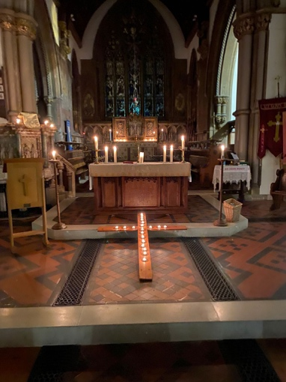
A lovely celtic service for All Souls was held on 31st Oct to remember our loved ones who we no longer see.

If you would be interested in attending an Advent Course please could you email parishoffice@rydeallsaints.org.uk to register initial interest. Day/Time yet to be confirmed

